CS 340 READ ME

**About the Project/Project Title**

This project was made to create a website for Grazioso Salvare for them to manage and organize the information of all of their animals they are tracking.

**Motivation**

Currently, Grazioso Salvare only has the data table I created for project one. This is not optimal as the data is not organized and is very hard to read, because of this we wanted to improve it by showing the actual location of the animal and show a graph of the animal percentages per page.

**Getting Started**

To begin I imported the logo of the company, designed a format for our data table and created code for geo location. This allowed me too create a more visually appealing website that showed the customer relevant information.

**Installation and use**

The tools used in this project are: jupiter dash, mogodb, and jupiter notebook

We used jupiter dash too provide the commands and formatting to create a website (espicially with the html commands) on top of this its documentation was very helpful with actually creating the project.

Mongodb was used too create, and manage our database and upload and take information from it.

Jupiter notebook was the service that hosted and ran my code for the entire project.

**Output:**

Attached below is an example of me selecting an animal and receiving the geo location as well as the graph of all animals on page.

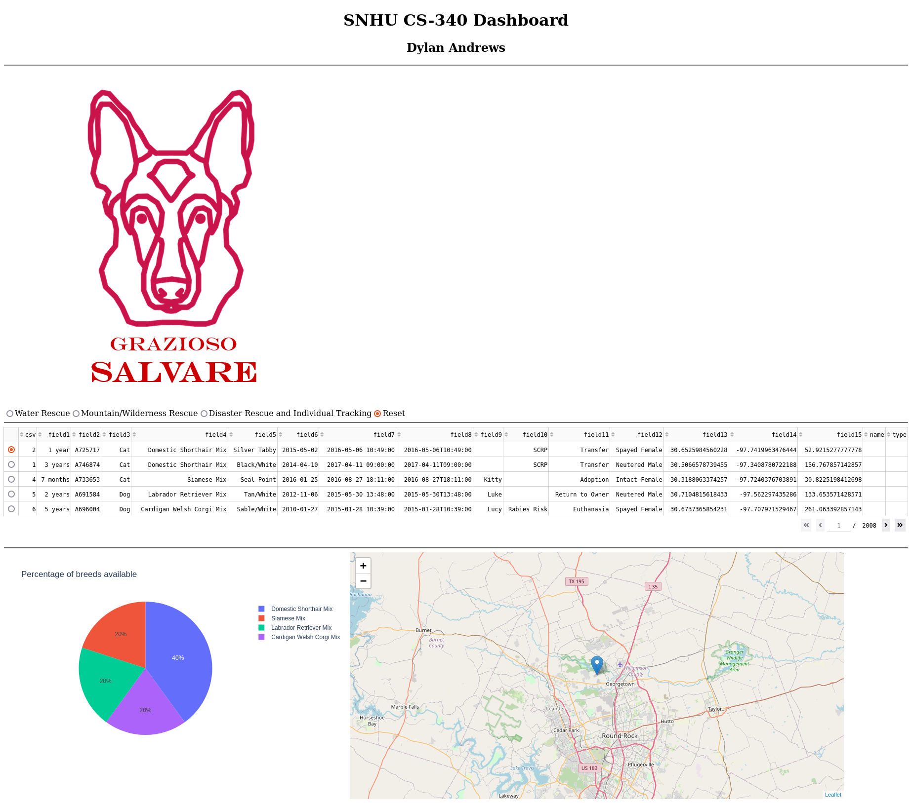

Problems with project:

I was very confused as too why sometimes when I clicked on a filter I could not see all relevant animals connected with that filter. This was because it only shows animals on that page with the filter however.

Contact

Dylan Andrews